DƐGA (MO)
people name Dɛga (sing Dɛg), meaning “multiplying”, “fertility”, etc.
by others by the Asante and many others “Mo”; by Hausa and others “Atoole”;
by Nafaanra “Jamoro” (language), “Jambie” (people);
by Gonja “Njomo” (language), “Kajomo” (people);
by Vagla “Bojoma” for both people and language.
language Dɛg (other names mentioned in Ethnologue Ghana 2003: Mmfo, Aculo,Janela, Buru)
home area Dɛg Harɛ about 1,700 sq km ?
other local peoples Gonja, Nafana, Hausa; Ewe fish in the Volta;
main towns New Longoro (Maantukwa) (pop in 2000 ?)
Bamboi (Gbambwe) (pop 2000: 2,679); altogether some 46 villages (A-A)
chiefs in 2010 Longoro Kooro: Nnaa Takyi Elaje II
Bamboikooro [one word or two?]: Nnaa Kwaku Dapaa II
name of God Korowii or Nnaa Korowijen or Nnaa Jana
principal local god Teo shrine at Old Longoro
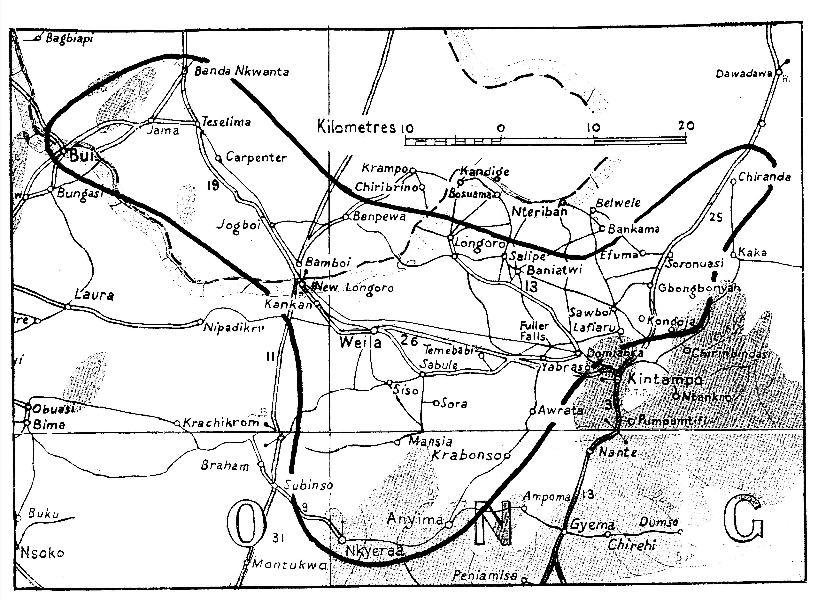

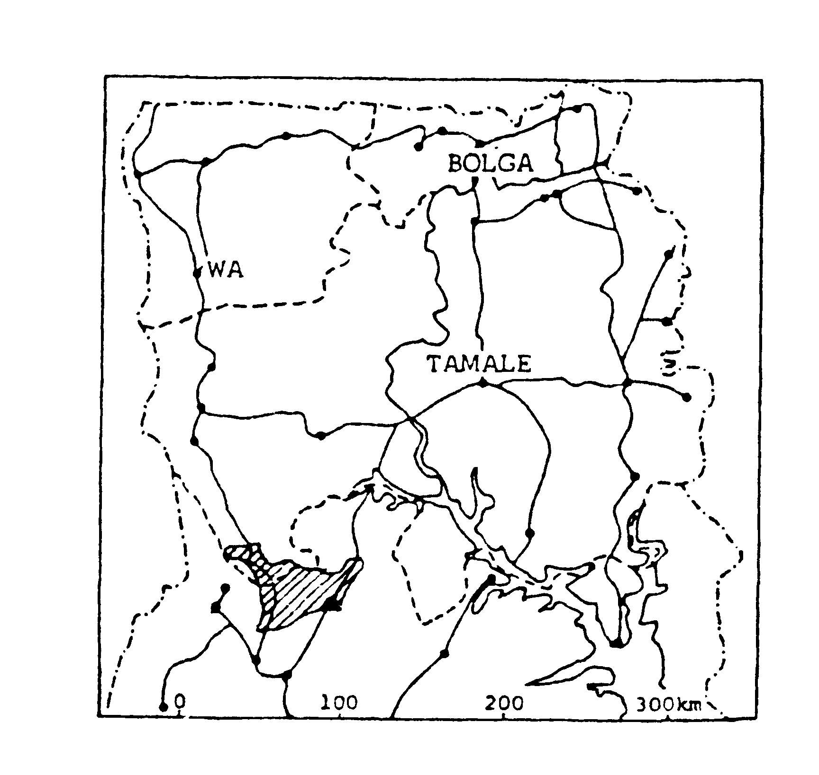
location Along the Côte d’Ivoire border, north-west of Wenchi; south of the Volta; in Brong Ahafo Region. Creation of the Northern Territories in 1908 divided this linguistic unit of some 46 settlements into a group of some 10 including Bamboi north of the Black Volta, now in Bole District, Northern Region; and 36 including New Longoro to the south, now in Kintampo District, Brong Ahafo; also 3 villages in Côte

AGRICULTURE AND FISH-FARMING AT CARPENTER*
Noah Ampem, manager of the Carpenter project, and Thomson Batieka, manager of the fish farm, interviewed by PB in 2008 * NW of Bamboi
A mixed agriculture project In 199? Dr David Mensah launched, with support from Canada and the USA, a Northern Empowerment Association (NEA), a mixed agricultural project at Carpenter. By 2010 it covered some 00000 sq metres, including a livestock farm, fish ponds, and nearly 30 buildings including 15 made with concrete blocks.
Empowering widows In 1997 the NEA started a project at Carpenter to help impoverished widows, disadvantaged by inheritance customs, to begin growing groundnuts. By 2010 some ?? [number please] women had passed through the project and become independent groundnut farmers. Their produce is stored in the NEA warehouses at Carpenter and Yaara, and marketed for them by NEA.
Stock farming started in 2000 and by 2008 they had 90 head of cattle, kept by expert Fulani herdsmen (see the Fulani chapter on pp 000-000), as well as grasscutters, goats, pigs, sheep, ostriches, and emus.
Crop and seed production began in 2003 with a vegetable garden. By 2006 they had three farms 3-5 km from Carpenter, where they grew 8 acres of rice and 70 acres of cassava; they supplied 10 lorry-loads of cassava to the gari factory. NEA became a certified seed grower and has built a grain dryer building.
Fish farming began in 2004. The fish hatchery complex in a warehouse at Carpenter now has 24 insulated glass incubator/nursery tanks each with electrically-powered aerator to supply oxygen and control temperature; and 27 concrete tanks where the fish are fed till they are ready for transfer to a outside fishponds. In the larger fishpond, which covers a hectare, fish are grown to their full size, to sell for consumption or for rearing.
Tree production Also growing at Carpenter are 8 acres of teak, one acre of oil palm, and 60 fruit trees (grafted mango, citrus, and a few guava).
Education Teachers from Northern, Upper West, and Brong Ahafo regions bring their students to see the project at Carpenter, and they take back with them a vision for what can be done even in infertile parts of the north.
Hernia repair NEA is planning annual visits by a Canadian surgeon to operate on the many patients in northern Ghana who wait in vain for treatment.
DƐGA POPULATION
Table 1 COMPARED BY YEAR
GHANA | 1960 Census | 1984 estimate | 2000 Census est.
3 N Regions | 8,720 | 17,440 | 20,198
7 S Regions | 110 | 199 | 34,976
GHANA total | 8,830 | 18,639 | 55,174
CÔTE D’IVOIRE (Taminge) | 1,100

Table 2 COMPARED BY REGION (2000)
3 Northern regions
Upper East | Upper West | Northern | NORTH TOTAL
2,535 | 6,247 | 5,178 | 13,960
7 Southern regions
Western | Central | Greater Accra | Volta
3,207 | 1,130 | 8,514 | 581
Eastern | Ashanti | Brong Ahafo | SOUTH TOTAL
1,316 | 5,450 | 21,016 | 41,214
GHANA Total |  |  | 55,174

MIGRATION
2000 Census figures above show 26,194 Dɛga in their homeland (21,016 in Brong Ahafo and 5,178 in Northern Region) out of a total of 55,174 in the whole of Ghana. They migrate to such places as Techiman, Tamale, Kumasi, Accra, and Abidjan in search of work and education, or to escape witchcraft. There are Dɛga communities in Kumasi at Bantama and Ahinsan.
Many work in rural Brong Ahafo and Ashanti; many female migrants run chop bars or do laundry work. Particularly in Abidjan they engaged in prostitution, but since 2000 there have been two opposite trends. The growth of girls’ education, AIDS education, and the death toll from AIDS have discouraged prostitution; at the same time AD reports increasing promiscuity among young people.
Some migrant communities appoint a Dɛg "chief", though this post does not involve the usual customary roles.
Some migrate annually and return to work on their own farms in Dɛg Hare when the rains begin. Others stay away for three years at a stretch, or even longer if they fear witchcraft at home, or if they have not succeeded in making enough money.
The migrants have formed a Mo Youth Association with headquarters in Kintampo and branches in other towns.
Migrant communities often appoint the oldest person as headman; individuals aim to build a house back in Dɛg Harɛ before returning home.
In recent years many younger people have migrated to Tinga, some 55 km NW on the Bole road, probably to work in a nearby gold mine.
The above figures mean that 37% of Dɛga (20,198) live in Brong Ahafo and the three northern regions. compared with 63% (34,976) living in the six southern regions excluding Brong Ahafo. Some migrate to Gonja, (NR) a) through intermarrying with Gonja; b) in search of work after completing training, because they trained in Tamale where school fees are less, and it is easier to find work there.
The National Mo Students Association (NAMOSA) was established in 1998 to promote peace, education, and development (contact details inc phone and name of one officer).
LANGUAGE AND DIALECTS
DƐG is a Gur language of the Grusi (west) sub-group related most closely to Vagla, but also to Isaaling, Tampulma, and Chakali, and, more distantly, to Kasem.
Dialects Longoro is spoken south of the Volta, Mangom on the north side and in 3 villages on the south.
Language use Twi is the trade language and is used in most main town churches for their worship and liturgies. The Dɛg NT is used for Scripture readings and individual prayers, but not by Jehovah’s Witnesses. In remote villages Dɛg is used throughout.
Kintampo District: Twi is taught in schools, and Dɛga are known for speaking it well.
Bole District: Since 2000 Gonja has been taught again in selected schools in the Dɛga area where there is a Gonja majority.
LITERACY/BIBLE TRANSLATION
GILLBT started work | literacy programme | NT printed | OT started in 1992
1981 | started 1982; by 2008 the supervisors included 6 paid, 9 volunteers, and 177 trainees | 1990 | whole of OT drafted by 2008
.
Students enrolled 2008 | male | female | total
basic stage | 100 | 87 | 187
advanced stage | 201 | 174 | 375
spoken English | 109 | 172 | 281
written English | 129 | 111 | 230
total | 539 | 544 | 1,073
(Information from Peter Chiu, Dɛg Project Coordinator)
Comments by users of the Dɛg New Testament “I thought I could understand the Asante-Twi Bible very well until I heard the parable of the labourers (Matthew 20:1-16) read in Dɛg” (member of SDA listening group).
“When Scriptures were read in Asante-Twi, my children used to ask me what they meant. Now they understand clearly.” (Hanna Anane)
“Whenever the Dɛg New Testament is read, the faces of members, especially the elderly and children, brighten up with smiles.” (Peter Chiu) (all quoted by A-A)
ORIGINS AND HISTORY (based on MC, DK, and A-A).
The Dɛga share with the Vagla and Tampulma the tradition that they formerly lived with the Sisaala but left after a quarrel over a dog's head (see an account at the head of the “Five Grusi” section). The Longoro Dega say they came from "Tiwii" in Sisaala country. For several alternative accounts see A-A pp 17-18. The migration is dated between 1600 and the early 1800s.
Though their language belongs to the Gur family centred in the 3 northern regions the Dɛga accepted an Asante invitation to be part of Asante, and the Longorokoro or Longoro chief was entitled Batakarihene on account of his distinctive northern smock. The Dɛga then adopted the Akan chieftaincy system. Chiefs sit on stools rather than skins, are carried in palanquins, and wear gold ornaments, which was previously taboo. Since 2000? succession has been limited to three gates, Paagu, Dankwa, and Leera.
In 1908 Dɛg Hare was divided along the River Volta between the Northern Territories and Ashanti. The Longorokoro’s petition that northern Dɛga should remain under the DC of Kintampo, not under the Gonja paramount chief, was refused. The division was confirmed in 1933 by the DCs of Wenchi and Gonja and again at the creation of Brong Ahafo Region in 1958. A separate paramount chief for the North Dɛga was not created till 1999. The two chiefs now cooperate although the Bamboikoro has lived in the USA for some 30 years, returning to Bamboi every year since he became chief.
From the 1940s to 1999 there was a series of destoolments, attempted destoolments, and costly litigation. Chieftaincy disputes “are certainly impacting negatively on the socio-economic development of the area” and have hindered social contacts between Dɛga north and south of the Volta (A-A).
Today there are some Gonja and Nafana villages in the Dɛga traditional area, but most of them speak Dɛg and their chiefs serve on the Dɛga Traditional Council.
THE COMPOUND, FARMING, AND DAILY LIFE
Hunting and fishing were the two principal occupations until both were undermined by use of damaging methods: uncontrolled hunting exhausted the stocks of all the species involved; fishing declined as a result of poisoning fish with DDT instead of by the traditional method - the juice from the bel plant that was inter-cropped with cassava. However in 2004 the Agricultural Development Bank sponsored a project at New Longoro to irrigate 535 acres and provide fish ponds for fish farming.
Mr Emmanuel Ataakorekpa, a teacher at Kintampo Sec Sch, started a private irrigation scheme on the south bank of the Volta at New Longoro in 1998 and by 2007 he was growing gratted mangoes intercropped with palm on 50 acres, and also keeping a 2 acre fish-pond stocked with local breeds of fish from the River Volta; the scheme is approaching the size at which he can employ workers.
There are also large fish-ponds along the Volta bank and many fish there using nets of different kinds. It proves hard to control use of illegal nets of too fine mesh.
Crafts Pottery and weaving; baskets? mats? pottery?
Farming, hunting, fishing Main cash crops include yams, maize, cassava, beans, cassava, cashew nuts, and calabashes. Dɛga hunters and fishermen settled along rivers: the Volta, Tain, Semel (GS Sameli), Wowo (GS Oyoko), Chegba is on the R Yeradea, R Nyembu, R Urukwain.
Cotton [ask Ataakorekpa]
Banks and credit unions The Catholic church in New Longoro runs a Credit Union which requires a member to save for 6 months to qualify for a loan twice the amount saved.
Markets Formerly the nearest markets were at Subinso, Kintampo, Techiman, and Wenchi. There are now markets at Bamboi and New Longoro (Saturday), Banda Nkwanta (Monday), and Chibenyoa (Tuesday).
Water Boreholes in most villages find the water table at about 70 ft.
Fuel There is still plenty of firewood in the bush, and even in towns charcoal is little used.
EDUCATION AND HEALTH
Education [details to be provided by regional office of GES]
Until 2006 the Dɛga area had no SSS at all. Before the Ghana Education Service can take responsibility for a new school the community must raise money to bring it up to the required standard.
Health (details to be provided by regional office of GHS)
Health Centres at New Longoro and Bamboi with medical assistants; Community Health Posts (CHPS) at Jama and Busuama
The commonest diseases are malaria, typhoid &c, &c [I’m getting Health and Education infm from regional Hqs
HIV/AIDS afflicts ?% of the population.
SERVICES
Police stations at New Longoro, Bamboi, and Kadelso
Transport Daily: Bamboi to Wa, Kumasi, Techiman, Wenchi, and Kintampo; also STC buses between Wa and Kumasi/Accra.
RELIGION
estimated %ages | Traditional | Muslim | Christian | No religion
1986 | 82 | 8+ | 8+ | ?
2008 | 20 | 20 | 45 | 15
Traditional Religion (A-A) (PH)
God is called Korowii or N Naa Korowii Jen, the Great Ancestor, who is the chief of all supernatural beings and spirits or a more ancient term, N Naa Jana, “the God who has always been there – from beginning to the end”. When sacrifices or libations are offered to the ancestors he is mentioned as being the head of all.
“God is seen as Spirit . . . as the chief of all spirits; he is too far away from humankind and can only be reached through ancestors, deities, and other spirits.”
Traditional religion has declined since the 80s.
Earth Earth is harɛ and is respected because it produces food and wealth; it is linked to the ancestors, so when any ritual is done a libation is poured on the earth.
Harɛ has neither shrine nor worship at Longoro or any village, but if someone steals or does something secretly to offend harɛ it will punish the offender by a snake-bite. Therefore when a snake bites a Dɛg we call it harɛ kpɔɔ meaning “the earth has taken vengeance”.
The harɛ tɛ or priest of the earth has revenue from various rights in the area, and out of these revenues he is responsible for providing animals for sacrifice (harɛ means ground or earth, tɛ means person). In addition, hunters may bring cash to provide an animal. Village chiefs provide the Longoro harɛ tɛ with cash for sacrifices made on behalf of the whole Dega people, for instance each year before bush-burning. The harɛ tɛ has power to send people to other villages to catch fowls for such sacrifices.
In villages the local odikro or headman of the village may also act as harɛ tɛ:
gods Teo is the main god of Dɛga. It has a shrine made of mud, like an ant-hill, at Old Longoro for all Dega, served by the Vogtɛ or shrine priest; many villages also have Teo shrines. Some are made of stones, others are not necessarily constructions, but just places, for instance under a tree.
A man may vow to give Teo a gift if he has good success over a certain period; he gives his gift to the Teo-kere-kpongri (Teo-knife-holder) in his village, and this person takes it to the Teo-kere-kpongri of the main shrine in Old Longoro, where the two knife-holders share the gift.
Families also keep clan gods and ask their permission before working on their farms. Other gods include Afafu at Old Longoro and Kosorobwɛ at Bɛwɛlɛ.
Family and personal gods, and powerful objects (often called fetishes) are owned by clans, households, and individuals. They may be obtained from other people or from shrines. A man believes his “fetish” casts a net over his house at night to keep witches away.
The “owner” of a god may prepare powders for use by farmers when making a new farm. Boro powder is mixed with shea-butter oil and put on a stone; it is then marked with dots or with a cross and dots; perewa powder may be blown over the farm. Both are thought to make the farm more fertile.
Ancestors The dead are believed to return to Lalabwɛ, the home of the dead, but “the dead still live among the living and want to be fed, so sacrifiices are made for them or food is kept for them on special occasions”. The dead are believed to be reincarnated, and to have power; so people pray to Korowii through them. Any venture people make in life may be preceded by divination; the dead are buried with items they will use in their ongoing life.
Diviners and herbalists Vogra = diviners (sing vogre) are still consulted to explain the cause of problems though they are individuals in various families and do not do this work as their livelihood. They may prescribe sacrifices to be made at the earth shrine or to a fetish, or libation to the ancestors.
Many chiefs follow the traditional religion, but one sub-chief became a Muslim and a number of village chiefs have joined various churches in recent years.
Festivals For Dɛga festivals see the chapter on Festivals.
Christianity
Conversion both to Christianity and to Islam can be quite superficial, and faced with common life problems many nominal converts seek to solve them in the traditional way; for instance boro and perewa powders may be used when making a new farm.
Among the attractions of the Christian way are the fact that Christian funeral is less expensive than the traditional form; fewer drinks have to be served. Christians have the reputation of living a good life, and the churches are respected for their medical work. However the rule against polygamy deters many people.
The Methodist Church came into the area in 1934 and the Christ Apostolic Church in 1948. The Catholics and Seventh-day Adventists came some years later but now have much larger communities than the Methodists and Christ Apostolics. The present Longoro Kooro is a Muslim, but most village chiefs belong to a local church.
The Evangelical Christ Apostolic Church (ECAC) was founded by Dr David Mensah in about 1992 as an offshoot of the existing Christ Apostolic Church. By 2009 the ECAC had assemblies in 29 locations including an ordained minister and a large church building in Bamboi, Some pastors have been trained at Christian Service College, Kumasi.
Many churches in Dɛg Harɛ saw their congregations double after the Dɛg NT became available.
Jehovah’s Witnesses started in Bamboi in 2004, when new Pentecostal churches also started work.
Islam
Islam is attractive because of the supposed power of amulets and prayers by the mallam, and because of the singing and dancing at Muslim marriages and funerals. Most traders are Muslims and non-Muslims are convinced that Muslims would somehow prevent them from taking up trading if they made the attempt. Many women convert to Islam through marriage. On the other hand Muslim prohibitions against drinking and the eating of meat not slaughtered in the Muslim way prevent some people from becoming Muslims.
Though Muslims are a small minority in the homeland, many migrants to southern towns found accommodation in Muslim zongos, and became Muslims there. The Dɛg NT and GILLBT literacy and “Scripture in Use” have no doubt limited this trend. For instance children in one Muslim Dɛg family in the south regularly read the NT and other Dɛg books.
The small number of Fulani herdsmen in Dɛg Hare are all Muslim, and they worship in local mosques.
SOURCES AND RELEVANT LITERATURE
PUBLISHED OR UNPUBLISHED ITEMS QUOTED
Thomas Atta-Akosah Bible translation in Christian mission (unpublished dissertation 2004) (A-A)
Marjorie Crouch, questionnaire answers, GEC, 1985
Felix Doni-Kwame, questionnaire answers, GEC, 1985
Patricia Herbert Exploring some of the issues of literacy, language and power in the context of development (unpublished MA dissertation, Reading University, 1990)
ORAL SOURCES
Noah Ampem, manager, NEA Project, Carpenter 0274 761765
Emmanuel Ataakorekpa Donkor, SDA, teacher, Kintampo Sec Sch 0243 537748
Edward Banchagla, Deg translator (has RC Ch Survey)
Gabriel Chiu, Registrar, Dega Traditional Council 0274 09352
Peter Chiu, Deg Project Coordinator and elder CAC 0277 236205
CONTACTS
Dr David Mensah, 0271 713828 061 28948
D A Nsiah, Deg Project 0274 150168
Fr Othmar, Catholic Mission

[My table of locations and churches was based on information from just two or three people. If you know anyone who could help to fill all the gaps I’d be grateful. I notice that it omits ECG. ]

CHURCHES AND MOSQUES (continued) [incorrect and incomplete table, please correct, and indicate which locations are in Northern Region and which are in Brong Ahafo]
c = congregation (number), p = pastor, priest, M = mallam or imam, b = church or mosque building
 | AF | Ang | CAC | Cath | CR | COP | ECG | ECAC | ME
Bamboi |  |  | cpb |  |  | c | Cpb | c | c
New Longoro = Matukwu |  |  | cb | cpb |  | c | C | cpb | cpb
Chibrungo |  |  |  |  |  |  |  | cpb
Teselima |  |  | c |  |  |  |  | c
Carpenter |  |  |  |  |  |  |  | C
Babatu |  |  |  |  |  |  |  | c
Krampo  Chiribrino |  |  |  |  |  |  |  | c
Chiribrino |  |  |  |  |  |  |  | c
Banpewa
Kpagto
Gbulumpe
Ampedu
Akrofonso
Dawadawa |  |  |  |  |  | SDA
Chiranda
Mandige
Bosuama  n |  |  |  |  |  |  | Cb
Nteriban |  |  |  |  |  |  | C
Belwele  Lo |  |  |  |  |  |  | cpb
Longoro
Bankama
Salipe
Efuma
Soreonuasi
Kaka
Gbongbonyah
Sawboi
Kanjoga
Lafiaru |  |  |  |  |  | c
Weila |  |  | cb |  |  | c | c
Yabraso
Domiabra
Cirinbindasi |  |  |  |  |  |  | cp
Kintampo |  |  |  | cpb |  |  | cp | cpb
Ayorya |  |  |  |  |  |  | c | c(b)
Mansia
Awrata
Jugboi |  |  |  |  |  |  | cb
Jama |  |  | cb |  |  |  | cbp | c
Jama Bates |  |  |  |  |  |  | c
Nkwanta |  |  |  |  |  | SDA | c
Chaara |  |  |  |  |  |  | c
Sabule |  |  | c |  |  |  | c
Subinso 1 |  |  |  |  |  |  | cp
Subinso 2 |  |  |  |  |  |  | cp | cb
Bniantwe |  |  |  |  |  |  | cp | cb
Felnyoa |  |  |  |  |  |  | c
Manchala |  |  |  |  |  |  | c
Branam |  |  |  |  |  |  | c | c
Sora |  |  |  |  |  |  | c
Asantekwa |  |  |  |  |  |  | c
Tikela No 1 |  |  |  |  |  |  | c | c
Ntaraban |  |  |  |  |  |  |  | c
tot congs 1986 | 7 |  |  | 22 |  |  |  | 6
tot pastor/priest | 2 |  |  | 3 |  |  |  | 1
tot buildings |  |  |  |  |  | c
tot congs 2008 |  |  |  |  |  | c
tot pastor/priest
tot buildings

 | Pent | PR | SDA | msq | prayr | imam | Educ | Health
Nkwanta | c | c | c | c | c
Chaara | c
Sabule
Subinso 1
Subinso 2
Bniantwe
Felnyoa |  |  |  | msq | prayr place | imam
Manchala
Branam
Sora
Asantekwa
Tikela No 1
Ntaraban
tot congs 1986
tot pastor/priest
tot buildings
tot congs 2008
tot pastor/priest
tot buildings
Nkwanta
Chaara
Sabule
Subinso 1
Subinso 2
Bniantwe
Felnyoa
Manchala
Branam

